1. Write a Java program for the sum of two numbers.

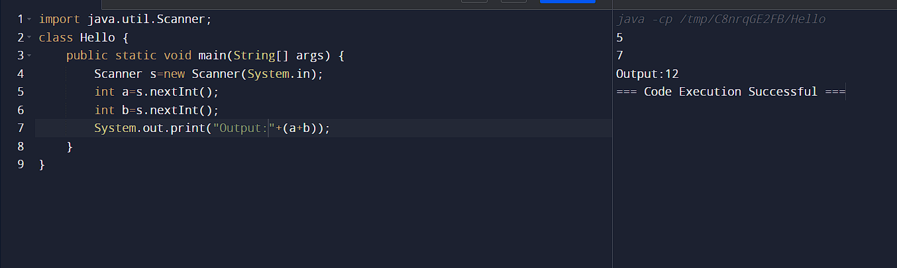

2. Write a Java program to calculate the area and circumference of the circle.

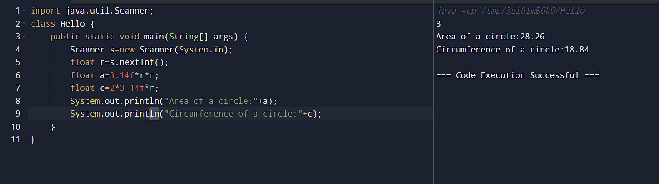

3. Write a Java program for arithmetic operations.

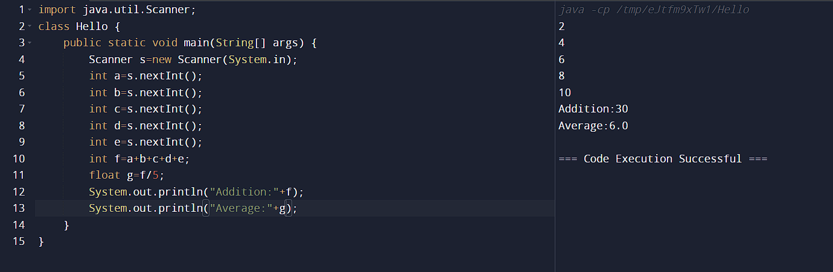

4. Write a Java program for the sum and average of 5 numbers.

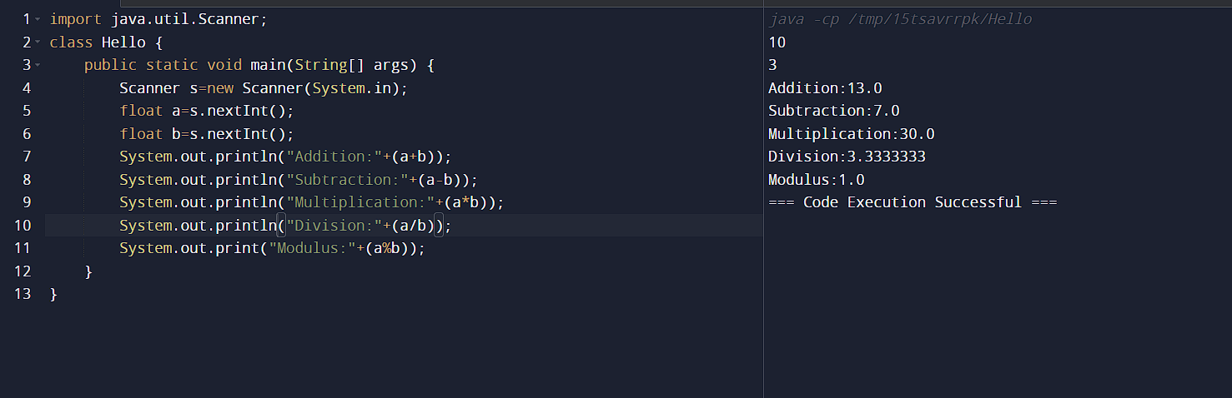

5. Write a Java program for the calculation of simple interest and compound interest.

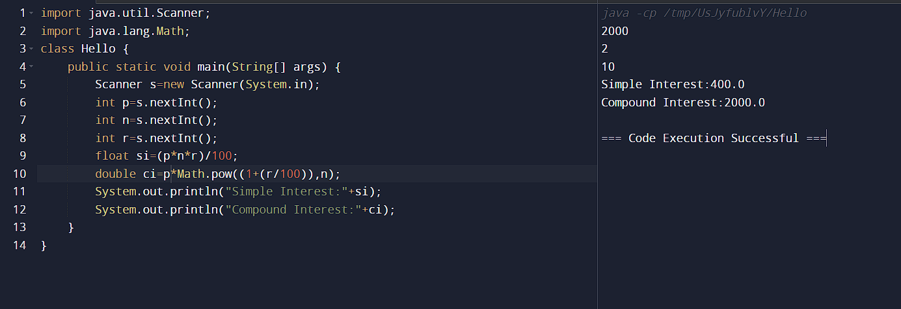

6. Write a Java program for print your home address.

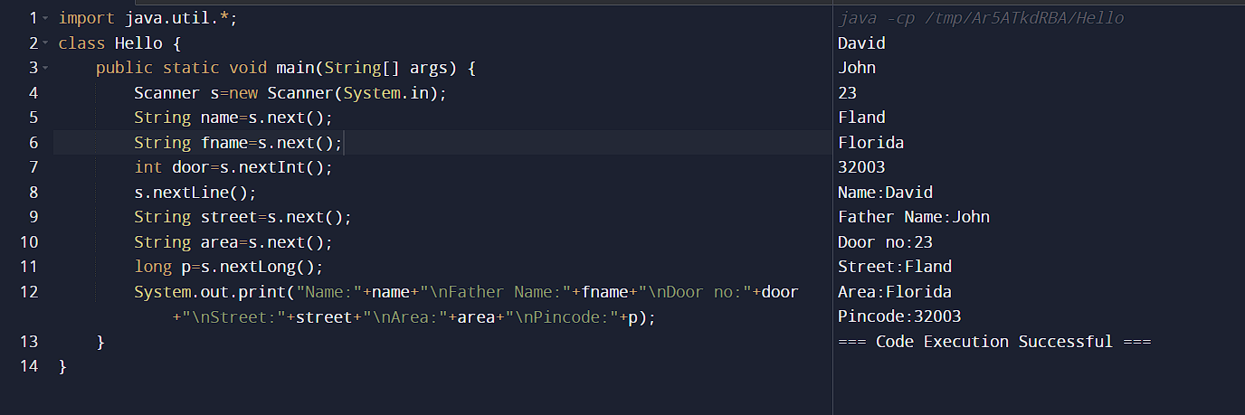

7. Write a Java program for the preparation of student reports and calculate the total and average for the student.

